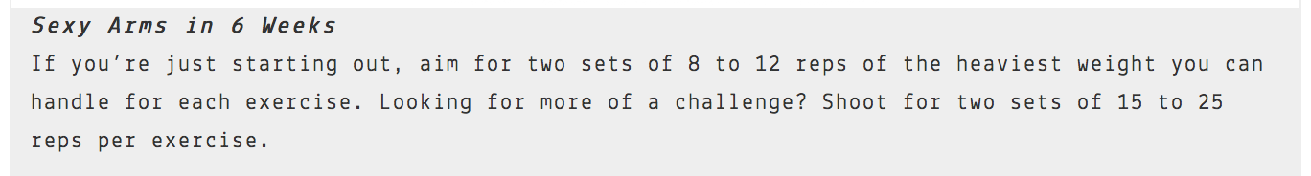

WEEK 1 | SUNDAY | MONDAY | TUESDAY | WEDNESDAY | THURSDAY | FRIDAY | SATURDAY
WEEK 2 | SUNDAY | MONDAY | TUESDAY | WEDNESDAY | THURSDAY | FRIDAY | SATURDAY
WEEK 3 | SUNDAY | MONDAY | TUESDAY | WEDNESDAY | THURSDAY | FRIDAY | SATURDAY
WEEK 4 | SUNDAY | MONDAY | TUESDAY | WEDNESDAY | THURSDAY | FRIDAY | SATURDAY
WEEK 5 | SUNDAY | MONDAY | TUESDAY | WEDNESDAY | THURSDAY | FRIDAY | SATURDAY
WEEK 6 | SUNDAY | MONDAY | TUESDAY | WEDNESDAY | THURSDAY | FRIDAY | SATURDAY

